DAY 3 -> 13-05-2026
Project 1: Customer Churn Prediction & Lifetime Value (LTV) Engine
Data Ingestion & Exploratory Data Analysis (EDA)
DONE BY -> ANANTHARAJAN V B
DATA SET PROFILING AND DATA UNDERSTANDING
Dataset Profiling
Dataset profiling is the process of checking and exploring the dataset before starting any analysis or machine learning work. In this step, the dataset is examined to understand how many rows and columns are present and what kind of information each column contains. We also check the data types, unique values, and overall structure of the data. For example, columns like customer age, monthly charges, or contract type help us understand customer behavior. This step helps in getting a clear idea about the dataset instead of directly jumping into model building. It also makes it easier to identify whether the dataset is organized properly for further processing.
Data Understanding
Data understanding focuses on learning how the data behaves and identifying possible issues inside the dataset. In this stage, missing values, duplicate records, and inconsistent entries are inspected carefully. For example, some customers may have blank values in important columns like total charges or payment method. By understanding these problems early, we can clean the dataset properly before training the model. This step also helps in understanding which features may strongly affect customer churn
DIFFERENT METHODS
- cmd → df.head()
use → Shows the first 5 rows of the dataset. It helps quickly verify whether the data has loaded correctly and gives an initial understanding of the columns and values.

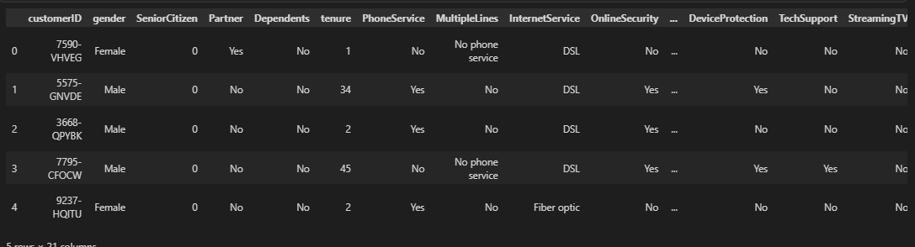
- cmd → df.tail()
use → Shows the last 5 rows of the dataset. It helps check the ending records and ensures the dataset looks consistent from top to bottom.

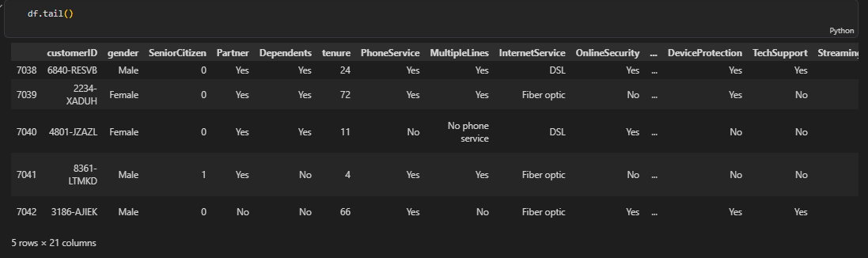

- cmd → df.sample()
use → Displays random rows from the dataset. This provides an unbiased view of the data instead of only looking at the beginning or end.

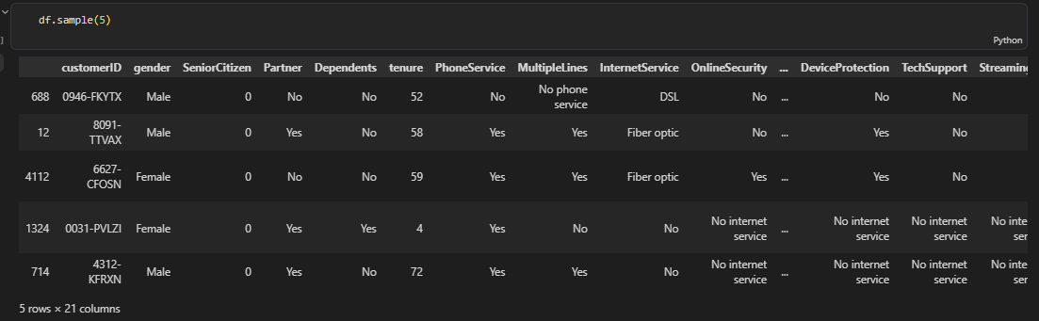

- cmd → df.shape
use → Returns the total number of rows and columns. This helps understand the overall size of the dataset before performing any analysis.

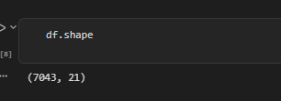
- cmd → df.columns
use → Lists all column names present in the dataset. This helps identify available features and understand what information is collected about each customer.
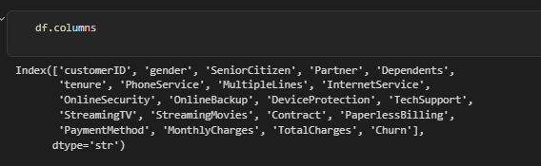

- cmd → df.index
use → Shows the row indexing structure of the dataset. It helps understand how records are organized and referenced internally.
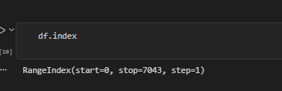

- cmd → df.info()
use → Provides a complete summary including column names, datatypes, non-null counts, and memory usage. This is one of the most important commands for understanding dataset quality and structure.
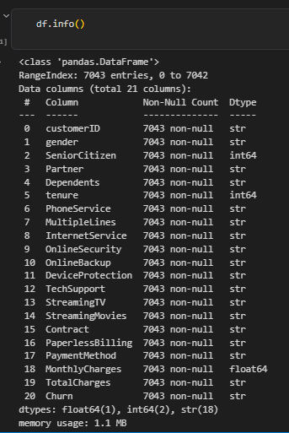

- cmd → df.describe()
use → Generates statistical summaries for numerical columns such as count, mean, standard deviation, minimum, maximum, and quartiles. It helps understand the distribution of numeric features.
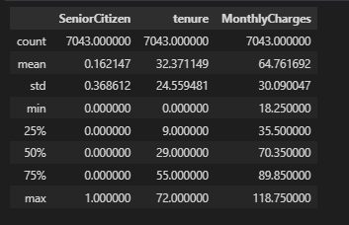

- cmd → df.describe(include='object')
use → Generates summaries for categorical columns. It shows the number of unique values, most frequent category, and frequency counts for text-based features.
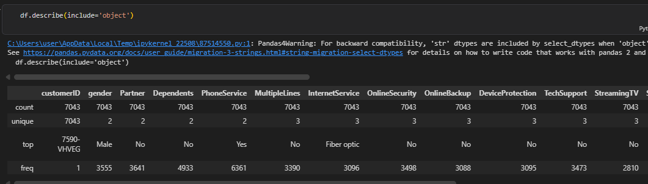

Identify Numerical Columns
use → Separates columns containing numbers from the rest of the dataset. Numerical features are commonly used for statistical analysis, scaling, and machine learning models.
10. cmd → df.select_dtypes(include=['int64','float64'])
use → Automatically identifies all numerical columns based on their datatypes. This is more efficient and reliable than manually listing columns.
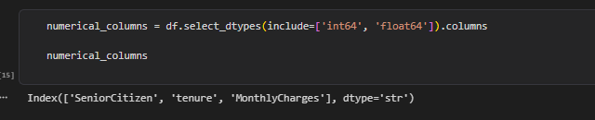

Identify Categorical Columns
use → Separates columns containing categories or text values. These columns often require encoding before being used in machine learning.
11. cmd → df.select_dtypes(include=['object'])
use → Automatically identifies all categorical columns stored as text. This helps prepare for future tasks such as encoding, frequency analysis, and visualization.

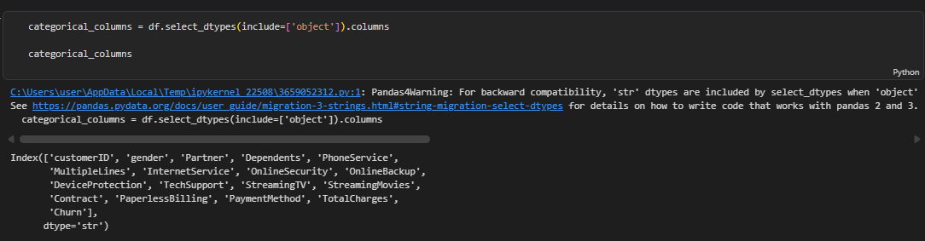

12. use → Counts how many numerical and categorical columns exist in the dataset.
